PROJECT DOCUMENTATION
Customer Care Registry
A MERN-Stack Complaint & Feedback Tracking System
Submitted by
Prathyusha Madala
GitHub Repository:
github.com/prathyushamadala25/Customer-Care-Registry

1. Abstract
The Customer Care Registry is a full-stack MERN application (MongoDB, Express.js, React, Node.js) built to centralize how a business records, tracks, and resolves customer complaints and feedback. It replaces scattered spreadsheets and manual logs with a single system of record: every complaint is captured with a category, priority, and status, moves through a defined lifecycle (Open → In Progress → Resolved → Closed), and is visible on a live dashboard so recurring issues and service trends surface early instead of being noticed only after they escalate.

2. Objectives
- Provide a secure, role-based system (customer / agent / admin) for logging and managing complaints.
- Maintain a complete, timestamped history of every customer interaction.
- Give staff a live dashboard view of open issues and resolution rates.
- Demonstrate a production-style MERN architecture: JWT authentication, protected REST APIs, and a componentized React frontend.

3. Technology Stack
Layer | Technologies
Frontend | React 18 (Vite), React Router, Tailwind CSS, Recharts, Axios
Backend | Node.js, Express.js, JWT authentication, bcryptjs
Database | MongoDB Atlas (Mongoose ODM)
Tooling | VS Code, Postman, Git & GitHub

4. System Architecture
The application follows a standard three-tier MERN architecture, with the React client communicating to the Express API exclusively over authenticated REST endpoints, and the API persisting data to MongoDB Atlas.
CustomerCareRegistry/
│
├── README.md
│
├── server/ ← Node.js + Express + MongoDB (API)
│ ├── package.json
│ ├── server.js ← entry point
│ ├── .env.example
│ ├── .gitignore
│ │
│ ├── config/
│ │ └── db.js ← MongoDB connection
│ │
│ ├── models/
│ │ ├── User.js
│ │ ├── Complaint.js
│ │ └── Feedback.js
│ │
│ ├── controllers/
│ │ ├── authController.js
│ │ ├── complaintController.js
│ │ ├── userController.js
│ │ └── feedbackController.js
│ │
│ ├── routes/
│ │ ├── authRoutes.js
│ │ ├── complaintRoutes.js
│ │ ├── userRoutes.js
│ │ └── feedbackRoutes.js
│ │
│ ├── middleware/
│ │ ├── authMiddleware.js ← JWT protect + role guard
│ │ └── errorMiddleware.js
│ │
│ └── utils/
│ └── generateToken.js
│
└── client/ ← React (Vite) + Tailwind + Recharts
├── package.json
├── vite.config.js
├── tailwind.config.js
├── postcss.config.js
├── index.html
├── .env.example
├── .gitignore
│
├── public/ (empty — static assets go here)
│
└── src/
├── main.jsx
├── App.jsx
├── index.css
│
├── components/
│ ├── Navbar.jsx
│ └── ComplaintCard.jsx
│
├── pages/
│ ├── Home.jsx
│ ├── Login.jsx
│ ├── Register.jsx
│ ├── Dashboard.jsx ← Recharts bar chart
│ └── Complaints.jsx
│
├── services/
│ ├── api.js ← axios instance + JWT header
│ ├── authService.js
│ └── complaintService.js
│
├── context/
│ └── AuthContext.jsx
│
├── hooks/ (empty — ready for custom hooks)
├── utils/ (empty — ready for helpers)
└── assets/ (empty — images/icons)

5. Database Design
Three core collections drive the application:
Collection | Key Fields
User | name, email (unique), password (hashed), role (customer / agent / admin)
Complaint | user (ref), subject, description, category, status, priority, assignedTo, resolutionNotes, timestamps
Feedback | complaint (ref), user (ref), rating (1–5), comment, timestamps

6. Key Features
- JWT-based authentication with secure password hashing (bcrypt).
- Role-based access control — customers see only their own complaints; agents/admins see all.
- Full complaint lifecycle tracking with status and priority.
- Live dashboard with real-time statistics and a status-breakdown chart.
- Persistent login sessions and protected frontend routes.
- Responsive, custom-designed UI (pine-teal / marigold-gold theme).

7. API Endpoints
Endpoint | Purpose
POST /api/auth/register | Create a new account
POST /api/auth/login | Authenticate and receive a JWT
GET /api/complaints | List complaints (own, or all for staff)
POST /api/complaints | Log a new complaint
GET /api/complaints/:id | Get one complaint
PUT /api/complaints/:id | Update status/details (agent/admin)
DELETE /api/complaints/:id | Remove a complaint (admin)
GET /api/users/profile | Get logged-in user profile
POST /api/feedback | Submit feedback on a complaint

8. Screenshots

8.1 Home Page

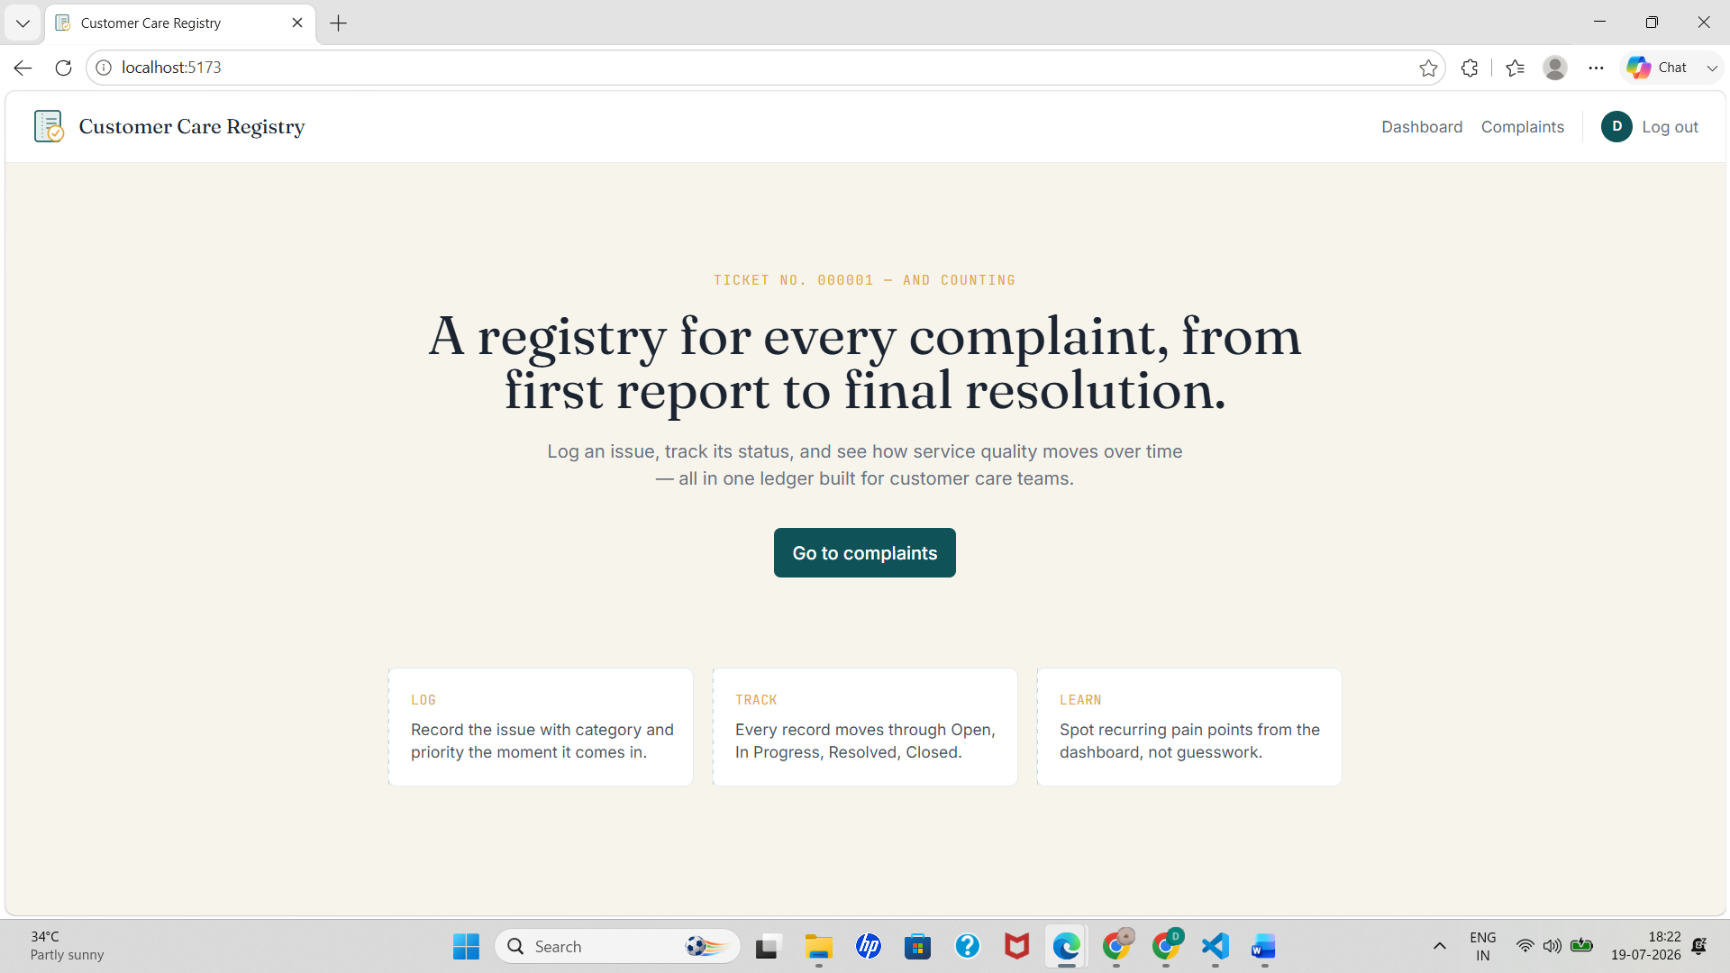

8.2 Register / Login

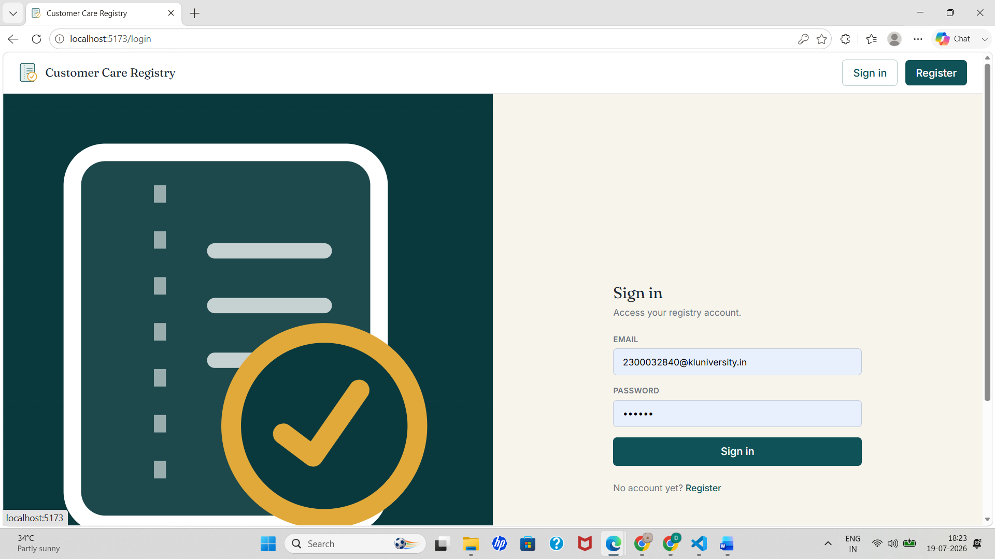

8.3 Dashboard

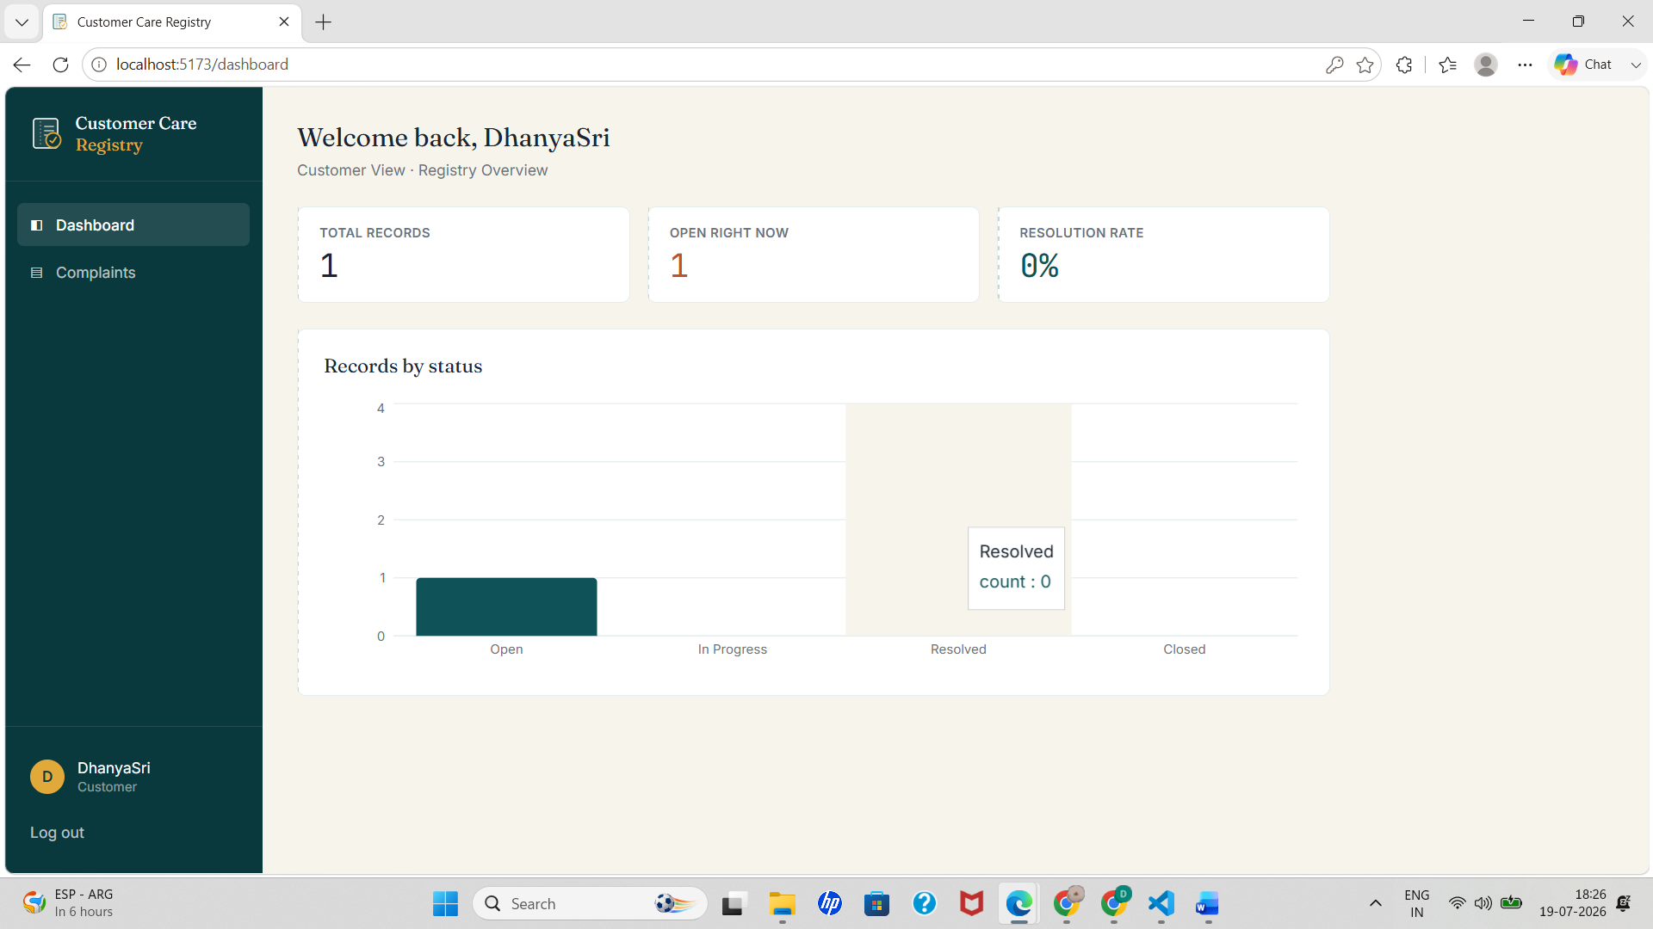

8.4 Complaints List

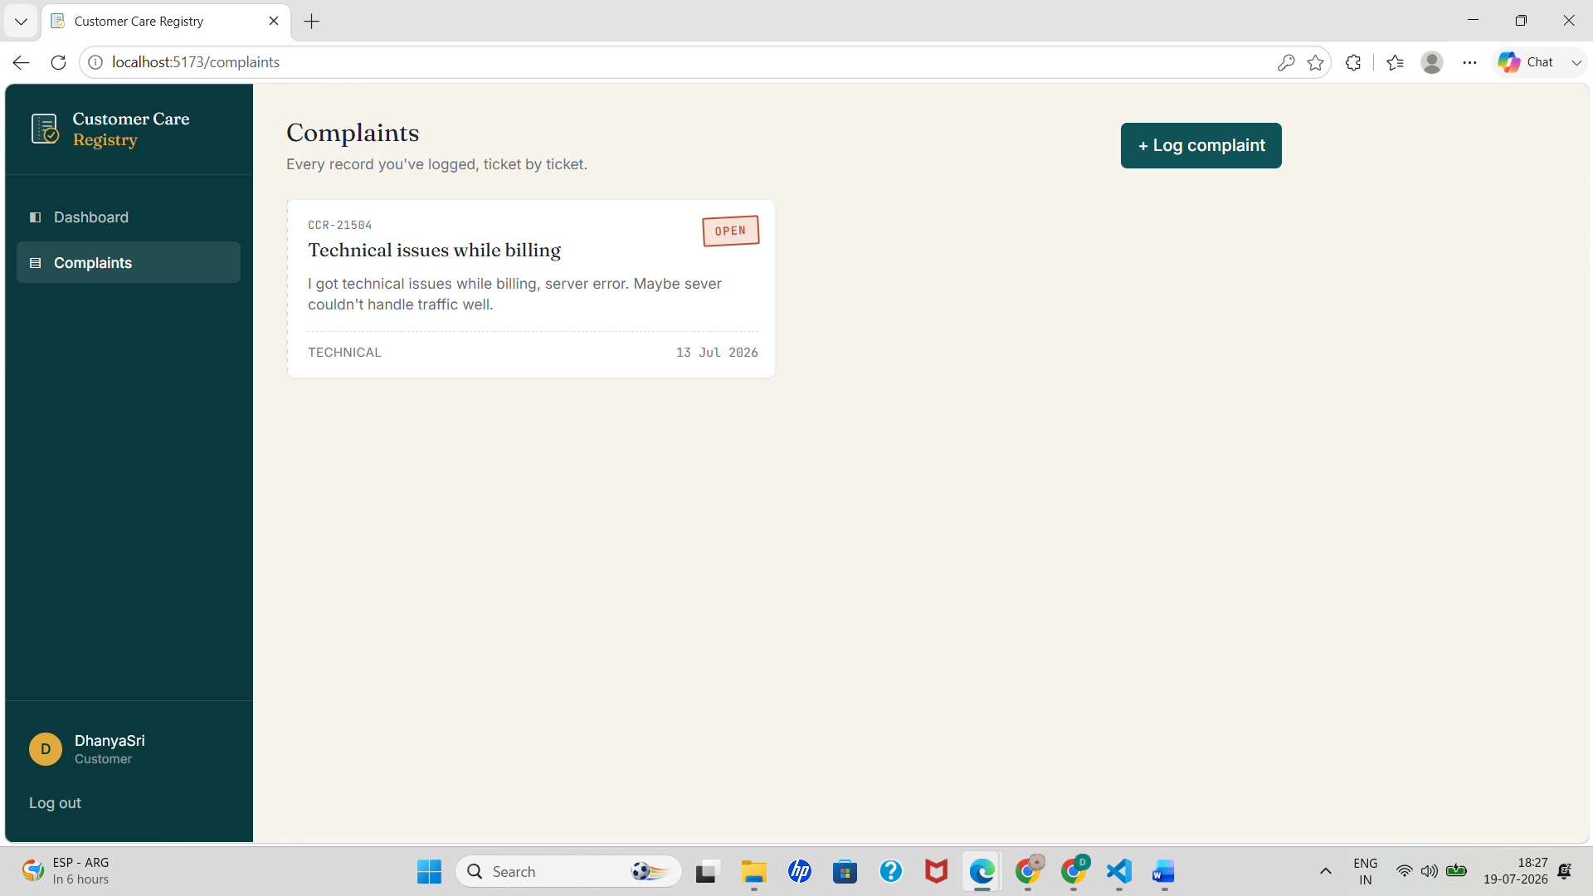

8.5 Log a Complaint

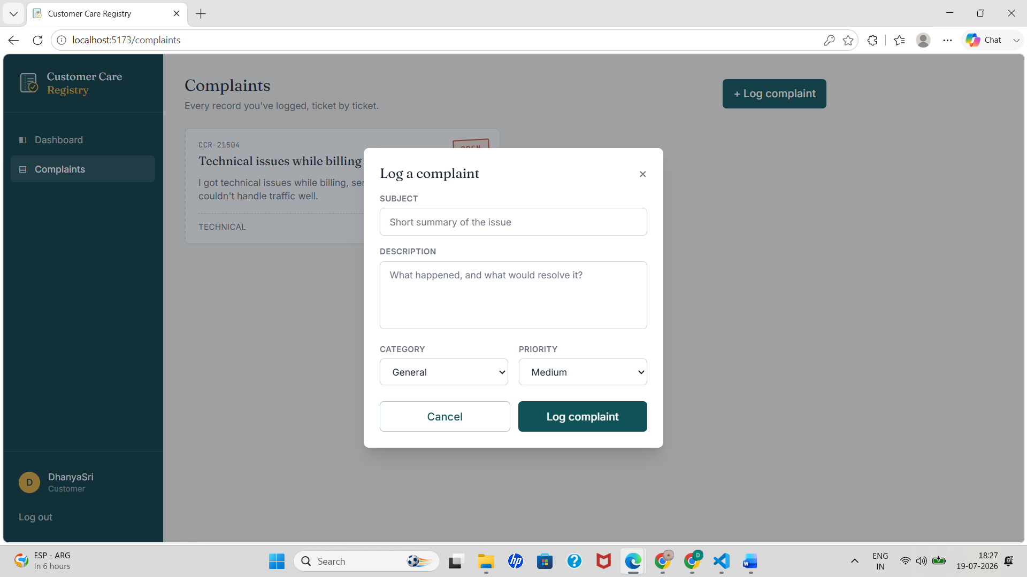

9. Installation & Setup

Backend
cd server
npm install
cp .env.example .env
npm run dev

Frontend
cd client
npm install
cp .env.example .env
npm run dev

10. Future Scope
- Email/SMS notifications on status changes.
- File attachments on complaints (screenshots, receipts).
- Agent performance analytics and SLA tracking.
- Customer satisfaction survey automation after resolution.

11. Conclusion
The Customer Care Registry demonstrates a complete, secure, role-aware MERN application — from schema design and JWT-protected REST APIs through to a polished, custom-themed React frontend. It fulfils the core goal of a customer care registry: a single, trustworthy record of every complaint from first report to final resolution.

